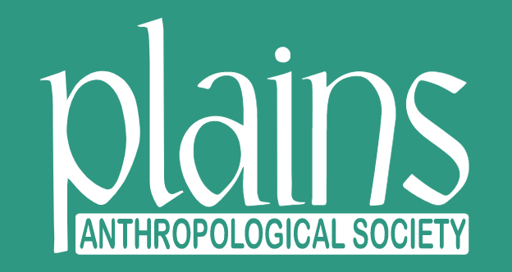

**2025 NOMINATION FORM**

PAS PRESIDENT

FOLLOWING CHANGES TO THE BYLAWS IN 2022, THE PLAINS ANTHROPOLOGICAL SOCIETY PRESIDENT WILL BE ELECTED FROM AND BY THE GENERAL MEMBERSHIP FOR A THREE-YEAR TERM. PLEASE MAKE RECOMMENDATIONS FOR PRESIDENTIAL CANDIDATES BY COMPLETING THIS FORM AND RETURNING TO: Timothy Reed, Nominating Committee Chair, treed@nd.gov

CANDIDATES MAY SELF NOMINATE.

NOMINATION DEADLINE: July 13, 2025

Nominee:

Title:

Affiliation:

Email:

IF NOMINATING ANOTHER MEMBER, PROVIDE A BRIEF RESPONSE TO THE FOLLOWING QUESTIONS:

Has the candidate agreed to be nominated? Yes No

Why would this person be an ideal PAS President?



**2025 NOMINATION FORM**

PAS PRESIDENT

IF SELF NOMINATED, PLEASE PROVIDE A BIOGRAPHICAL STATEMENT AND ADDRESS THE FOLLOWING QUESTIONS. IF NOMINATING ANOTHER MEMBER, THE NOMINATIONS CHAIR WILL CONTACT THEM FOR THE FOLLOWING INFORMATION, WHICH WILL BE SHARED WITH MEMBERSHIP PRIOR TO THE ELECTION.

Biographical Statement:

If elected, what can you contribute to the Plains Anthropological Society, and what priorities would you emphasize?



PAS PRESIDENT

**EXPECTATIONS**

* I understand that the term of PAS President is three years (one year as President-Elect, an *ex officio* Board position, followed by two years as President).
* I recognize the importance of attending the Plains Anthropological Conference during the election year and the following three years of service (four years total).
* As President, I will organize and run meetings as needed, including virtual and in-person gatherings before and during the annual PAS conference.
* I will communicate and work with regular and *ex officio* members of the Board of Directors (BOD), conference organizers, and others to resolve PAS issues and implement my priorities.
* I am cognizant of the commitment needed to serve as PAS President.
* I understand that taking on the role of President of the Plains Anthropological Society will require sometimes significant dedication of my time, particularly leading up to and at the annual meeting.
* I understand that in this position, I will be expected to lead the organization, in conjunction with the BOD, and will work to my upmost ability to fulfill this obligation with the best interests of the Plains Anthropological Society in mind.