PLAINS ANTHROPOLOGICAL SOCIETY
STUDENT PAPER COMPETITION ENTRY FORM
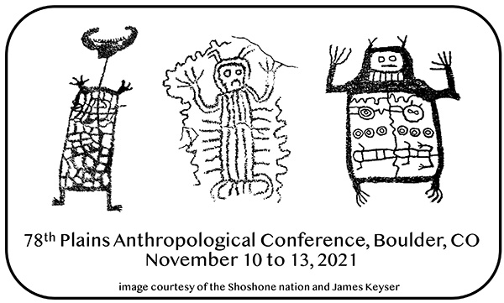

Name: _________________

Title of paper: __________________________________________________________

Institutional Affiliation: ________________

Address: ____________________________________________

Address: __________________________________________________

E-mail: __________________________

Major/Program: ______________

Undergraduate or Graduate Student: ______________

Advisor/Mentor for this paper: ______________

Advisor’s E-mail: ___________________

This form must accompany all papers submitted to the Student Paper Competition. Submissions must follow the published guidelines. All students are responsible for submitting an electronic copy of the paper in advance of the conference. (https://plainsanthropologicalsociety.org/grants/student-paper)

